Irregular Verb Past Tense Word Search
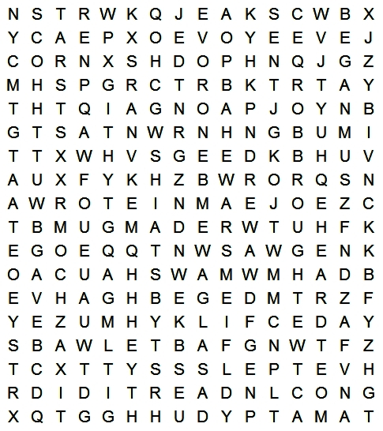 |  |  |  |  | Write the past tense next to each of the verbs below. Then, find the past tense of the verb in the grid to the lift.  
begin |  | get |  | say
blow |  | give |  | see
bring |  | go |  | send
buy |  | grow |  | sing
catch |  | hear |  | sit
come |  | know |  | sleep
do |  | make |  | swim
draw |  | meet |  | take
drink |  | read |  | throw
eat |  | run |  | write

© 2009 Lanternfish ESL at www.bogglesworldesl.com

