United States of America

The capital of the United States is Washington, D.C. The population is 300 million inhabitants. There are 50 states and a few territorities, such as the Virgin Islands, Guam and Puerto Rico. Canada and Mexico border the USA to the north and south.
Independence day is the Fourth of July. The United States gained independence from Great Britain in 1776. We are close friends with Great Britain today.
The current president is George W. Bush. He is the 43rd president. The next election for the 44th president will be in November 2008.
The flag of the United States is red, white, and blue. There are 50 stars for the 50 states and 13 stripes for the 13 original colonies.
There are several different regions in the USA. New England is located within the Northeast, along with the Mid-Atlantic states. The Midwest is located in the north. The West and South are located in the west and south, of course.

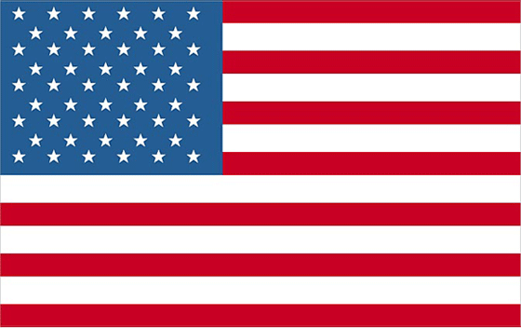

1. ?

There are fifty states.

2. ?

Washington, D.C. is the capital of the United States.

3. ?

Independence Day is the Fourth of July.

4. ?

George W. Bush is the president.

5. ?

There are 50 stars on the flag because there are 50 states.

6. ?

New York City is in the Northeast.

7. ?

The Midwest is a region of the United States.

